|  |  |  |  |  |  |  |
| --- | --- | --- | --- | --- | --- | --- |
| **BTC: $7,843.59       ETH: $246.61       XRP: $0.403691 Become Our Sponsor** | | | | | | |
| 165841-425x319-enviroslogan3  Home | Our Story | Members | Get Involved | Achievements | Blog | Contact Us |

|  |
| --- |
| **PROTECT AND SAVE THE EARTH AND OUR ECONOMY!**  **Lorem Ipsum** is simply dummy text of the printing and typesetting industry. Lorem Ipsum has been the industry's standard dummy text ever since the 1500s, when an unknown printer took a galley of type and scrambled it to make a type specimen book. It has survived not only five centuries, but also the leap into electronic typesetting, remaining essentially unchanged. It was popularised in the 1960s with the release of Letraset sheets containing Lorem Ipsum passages, and more recently with desktop publishing software like Aldus PageMaker including versions of Lorem Ipsum.  **Read More** |

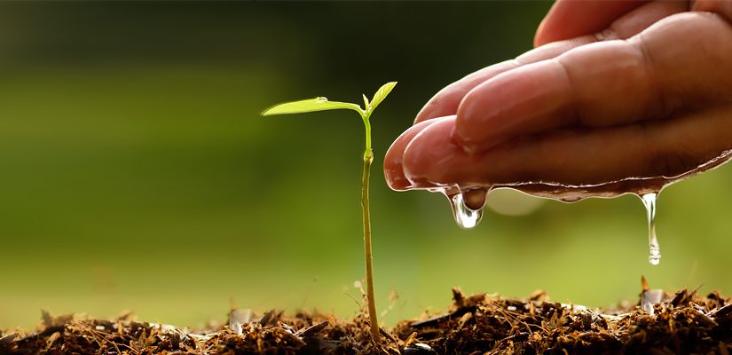

**Saving the Earth in every crypto transaction you make.**

**9,158 Trees Planted**

**Plant More Trees**

**Crypto for a better tomorrow.**

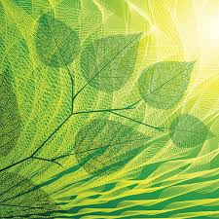

**Let’s Plant!**

**Transact more, plant more!**

****Lorem Ipsum** is simply dummy text of the printing and typesetting industry.**

Name:

Email Add:

Wallet Add:

**Plant Now!**

**Top 10 Wallets**

|  |  |
| --- | --- |
| **1,354 Trees**  0x6233837716046440DF1aDe953F918300E7c7A0c1 | **1,354 Trees**  0x6233837716046440DF1aDe953F918300E7c7A0c1 |
| **1,354 Trees**  0x6233837716046440DF1aDe953F918300E7c7A0c1 | **1,354 Trees**  0x6233837716046440DF1aDe953F918300E7c7A0c1 |
| **1,354 Trees**  0x6233837716046440DF1aDe953F918300E7c7A0c1 | **1,354 Trees**  0x6233837716046440DF1aDe953F918300E7c7A0c1 |
| **1,354 Trees**  0x6233837716046440DF1aDe953F918300E7c7A0c1 | **1,354 Trees**  0x6233837716046440DF1aDe953F918300E7c7A0c1 |
| **1,354 Trees**  0x6233837716046440DF1aDe953F918300E7c7A0c1 | **1,354 Trees**  0x6233837716046440DF1aDe953F918300E7c7A0c1 |

**Partners & Sponsors**

